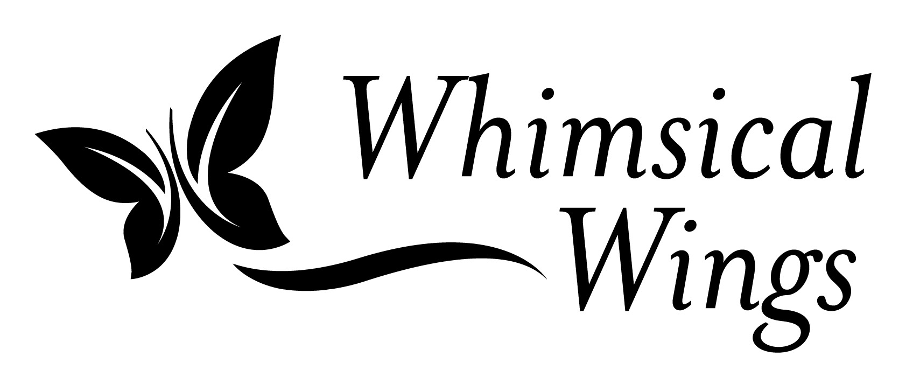

Classroom Comparison Chart
Caterpillars in a Cup vs Monarch Butterfly Kits
Provided by Whimsical Wings Farms
www.whimsicalwingsfarms.com
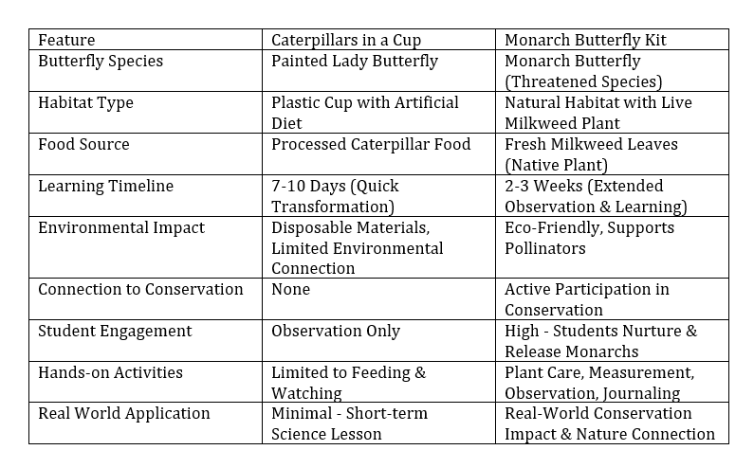

Why Teachers Everywhere Are Rethinking Caterpillars in a Cup
Most of us grew up with the same kit: Caterpillars arrive in a plastic cup. They eat a mystery gel or processed food. They quickly transform, and then the fun is over. But is it really the best way to teach this lesson anymore? At Whimsical Wings Farms, we believe there's a better, more inspiring way. It's hands-on. It's eco-friendly. And it just might be the classroom upgrade your students will never forget.
Caterpillars in a Cup teaches a life cycle. Monarchs teach a life story. Give your students the kind of science lesson they'll remember forever. Learn more by emailing help@whimsicalwingsfarms.com.

